The Synthetic Chemist User’s Guide

K. K. Agarwal
H. L. Gelernter
G. A. Miller
April 2009

Table of Contents

TSC – the only automatic synthetic chemistry program

1. Introduction

After about 40 years of research, we have finally decided to release a part of TSC (The Synthetic Chemist, previously known as SynChem) - the one and only synthetic chemistry program developed at the State University of New York at Stony Brook under the direction of Dr. Herbert L. Gelernter. This program is an application of artificial intelligence to the field of organic chemistry. Development of the first version of the program was begun in 1965. SynChem1 was designed to operate without interaction with a chemist. Its inputs were a) the structure of the molecule whose synthesis was desired, b) a reaction library, and c) a list of commercially available compounds. The program was written in a combination of PL/I and assembly language to operate on an IBM 360 mainframe.

Work on SynChem2 was begun in January of 1973. The program was rewritten to eliminate the unmaintainable assembly language programs. Also, many improvements were made. “Slings” (SynChem Linear Input Graph) were invented to uniquely represent the structure of every molecule developed by programs in the TSC system. They, essentially, provided a computer-based nomenclature system that included stereochemistry. Unfortunately, although subgoal generation was completed to handle stereochemistry, the reaction library and other modules could not be modified to do the same. All programs were still on the IBM 360 mainframe and written in PL/I.

The next version of TSC was begun in 1980 for the SUN system of computers. Hence, the language of choice was C. This developmental effort lasted until the year 2000. Extensive revisions were attempted to make the program more interactive and error-free, although, we recognize that a large system can never be completely bug-free.

We have decided to release this version of TSC to the general community of synthetic chemists. We recognize TSC as an invaluable assistant to the professional organic chemist who wishes to undertake the synthesis of complex organic molecules. The current program is available for Linux (Ubuntu 8.10 version) to execute on an IBM PC-compatible computer. This user’s manual is for novice users who wish to get started with TSC.

2. What is TSC?

The TSC system is a large-scale software tool that offers substantive and cost-effective assistance in addressing an important and often very difficult class of problems faced by most producers of complex, high-value organic chemical compounds such as pharmaceuticals, agricultural chemicals, agents required in the manufacture of semiconductor materials and information storage media, and so on. The problem is that of discovering a sequence of (usually) known, controllable, and outcome predictable chemical reactions that will transform available starting materials into a desired target compound. With relatively minor additional development, the problem domain accessible to TSC may be expanded to include prediction of the products of environmental and metabolic breakdown, so that the risks and consequences of releasing a substance into the biosphere or ingesting it may be quickly and accurately evaluated.

In brief, TSC is a knowledge-based domain-specific heuristic problem-solving system that applies the methodology of artificial intelligence to the problem domain of organic chemistry. The program may be used for both retrosynthetic and synthetic exploration of a reaction transform space. It was designed to enable the practicing organic chemist to discover valid synthesis routes for organic molecules of interest without requiring that he provide on-line guidance to the program. Even with its presently limited library of known synthetic reactions, TSC has proposed synthesis routes that have been judged useful, original, and suggestive by chemists who have used the system. Only an enlarged and stereochemistry-enabled knowledge base (the synthesis search engine is already fully stereo-search capable), which will be acquired via the machine learning techniques pioneered is required to transform the existing TSC system into a stereochemistry software product.

3. How does TSC work?

TSC begins its search with a drawing of an organic molecule. It examines the molecule for certain features (functional groups) that can be synthesized. It then consults the reaction library, checking each reaction schema to determine whether it can be used to synthesize one of the groups it found in the target molecule. If it finds a match, it checks whether any other functional groups in the molecule could interfere with the reaction, or whether any other group that is required is missing, by applying pre-transform tests. If the schema passes the initial tests, TSC tries to match up all the atoms and bonds in the pattern for the reaction to atoms and bonds in the molecule. It does this for each location in the molecule that contains the functional group(s) required by the reaction schema. If at least one complete match is found, the schema is applied by breaking certain bonds and creating others to generate one or more subgoal molecules. Before accepting the results of applying the schema, TSC examines the new information that has been generated by the application, based on the list of post-transform tests for the schema. These tests may either fail the subgoal completely or else accept the molecule with or without adjustments to the reaction transform merit factors of ease, yield, and confidence. Every subgoal that makes it this far is stored as a branch descending from the goal molecule in the problem-solving tree, with the molecule(s) it contains stored as children of the goal molecule. Each subgoal molecule is assigned a compound merit based on its complexity, and each reaction application is assigned a merit that combines the post-transform test results with the merit(s) of the subgoal molecule(s). Certain molecules will be given a merit of 100, because they are found in the list of available compounds. If all the compounds in a subgoal are either found to be available or are solved elsewhere, the subgoal is considered to be solved, as is the compound for which it was generated. When the entire reaction library has been searched, the first cycle is complete. The best merit among the subgoals is used to improve the merits along the branch(es) of the tree that contain the ancestors of those subgoals. After the information developed in the subgoal generation cycle has been propagated throughout the search tree, the entire tree is examined for the best path to pursue at that stage of the search, taking into consideration the amount of time already spent on each developed branch as well as the estimated promise of that path. Results of the perusal of the complete search space are used to select the next compound to be developed. This compound becomes a new target, and the entire process repeats until either the allotted time or the allotted number of search cycles has been exceeded. What the chemist sees at the end of a search is a symbol for the target compound with a number of lines descending from it, each of which is attached to a subgoal (one or more symbols tied together), with another set of lines below one of the symbols for the subgoal molecules, showing the list of subgoals generated at that level. The chemist can click on any of the symbols to look at other parts and levels of the tree or to look further down the displayed path for a solution, if indeed any lie below that node. A separate panel exhibits a drawing of the reaction that corresponds to the part of the tree that is currently being displayed. The shape of a given symbol tells the chemist the status of that part of the tree (see Figure 1 below):
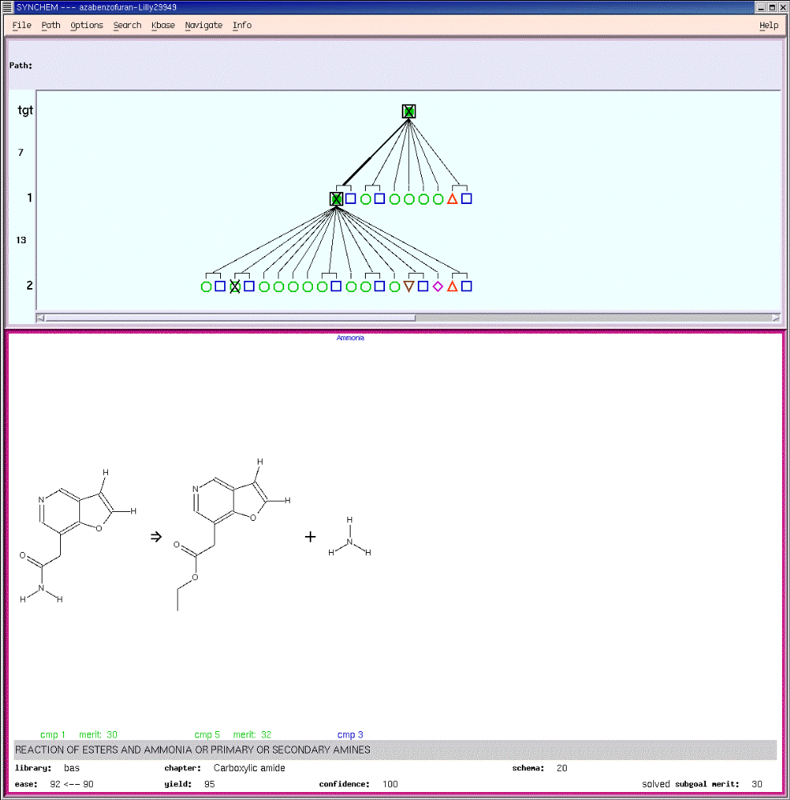

Figure 1

1. Red triangle:
Stuck or unsolvable (there is no more chemistry to take it any further).

2. Magenta diamond:
Undeveloped (TSC hasn’t yet done anything with the compound).

3. Brown inverted triangle:
Developed (TSC has selected this compound for expansion, but so far, there is no solution for it).

4. Green circle:
Solved (somewhere, further down this path, it terminates at available compounds).

5. Blue square
Available (found in the list of available compounds). The chemist can mark certain paths that he finds especially interesting or promising and save them to a file for future reference. He can also use these saved paths to display a synthesis in a format that is closer to what he would expect to see published in a chemical journal as a synthetic scheme.

4. What remains to be done?

Knowledge Base Development: Upgrade existing TSC machine learning algorithm for inductive extraction of reaction generalizations from computer readable reaction databases from its current research-level performance to a production-grade system. This will enable us to enlarge the existing reaction library by a factor of ten, enhance its reliability, and maintain and update the reaction library to reflect a timely knowledge of current chemistry. This would need the expertise of a Ph.D.-level expert in synthetic organic chemistry, a Ph.D.-level expert in machine learning, a systems programmer, a database specialist, and one support programmer with licensed access to computer-readable reaction databases.

Stereochemistry: Upgrade existing knowledge base and graphical user interface (GUI) to represent stereochemistry as reflected by the existing stereochemistry capable search engine. This will need a Ph.D.-level synthetic organic chemist and a programmer.

Metabolic and Environmental Chemistry: Build a library of specific reactions capable of predicting the metabolic fate of ingested substances and the environmental fate of chemicals released into the biosphere. This will need a Ph.D.-level health and environment chemist and one systems programmer.

Internet Strategy: Develop Java applets to facilitate graphical input of target molecules and recast the GUI as an ensemble of CGI scripts to enable local perusal of search output. This will need a web-design programmer.

5. Planning a synthesis

The SynView program is all one needs to interact with TSC. You must select the Search button from the main menu to Submit a molecule. A drawing program takes over and helps you draw a molecule for input to the TSC search engine. The drawing program is named DrawPad and is documented in the box below.
DrawPad

File menu:
1) Open - submit … (brings up a file selection window positioned within the submit directory - select a file from which the sling and other data are to be read and displayed)
2) Open - status ... (brings up a file selection window positioned within the status directory - select a file from which the sling and other data are to be read and displayed)
3) Save - submit... (writes file named in Run ID box to contain text from User, Date, Comment and Sling boxes - be sure to fill in Run Id and Comment, and update Sling by clicking Done button prior to saving)

Options menu (Directories):
If you have opened a submit file that was created for a different installation of SynChem, you will have to click the Reset button in the popup window to make its directories consistent with the location of the current knowledge base.

Draw button: restores the last molecule drawing submitted during this session.

draw_sling_templates button: brings up a file selection window positioned within the draw_sling_template directory - select a file from which the sling and other data are to be read and displayed)

Reset button (top): clears RunID, Comment, and Sling fields

DrawPad (continued)

Maximum Cycles, Maximum Time (minutes); Reset: determines criteria for automatic termination of SynChem run, i.e., when either value is exceeded; button resets Maximum Cycles to 1000, Maximum Time to 120, and additional fields to 0

Edit Mode buttons:
1) draw: enables "rubber-band" connection of atoms to one another
2) select: enables freehand drawing of an enclosed area around part of a drawn molecule, usually for wholesale deletion
3) delete: changes drawing cursor to "skull-and-crossbones," which when placed over an atom or a bond highlights it for deletion when the left mouse button is clicked

Edit Options buttons:
1) select all: draws an enclosure around the entire molecular drawing
2) delete selected: deletes all atoms and bonds enclose by the selection area

Atoms buttons (change current atom identity - selecting "other" brings up a periodic table)

Bonds buttons (change multiplicity of last-drawn bond)

Drawing Area:
1) use left mouse button to lay down an atom (C by default)
2) if necessary, change the atom ID from the appropriate Atoms button
3) lay down a bond to the next atom by moving to the position and pressing either the left (single) or middle (double) button
4) if necessary, change the bond order from the appropriate Bonds button
5) to move without adding or modifying a bond, press the right mouse button

done button (updates Sling box from contents of drawing area)

redraw button (cleans up drawing by showing a - usually - more pleasing template-generated rendition)

clear button (erase drawing area)

submit button (accepts molecule as defined by drawing for validation process)

cancel button (bypass validation process)

reset button same as Reset button, but also clears drawing window and restores other fields to their defaults
Hence, a molecule is normally drawn by dragging the mouse (with the left button pressed) to draw a chain of carbon atoms. By selecting the Atoms button, the type of atom at any position can be changed. When done with a portion of the molecule, the right mouse button is pressed to stop drawing bonds. The mouse can be moved to another position on the molecule and the drawing can be continued. The type of bond can also be changed by selecting the correct Bonds button by dragging the mouse to either a double or a triple bond button. When the molecule drawing is finished, the redraw button is normally recommended to get a clearer picture of the molecule. The run-id is the name of the file the status information will be saved in. Finally, the done button is pressed to get the Sling of the molecule.

If a molecule that has been drawn already must be submitted, the Open –status button is used to select the appropriate file which contains the saved molecule. It is recommended that the Options – Directories buttons be used to reset the directories to be used for the synthesis run. Also, use the Options- Files buttons to Save the Status and Trace files. Normally, the Trace Level is left at 1 to produce a nominal amount of trace information. To debug TSC errors, a higher trace level is used occasionally.

Under Exit Conditions, enter the Maximum Cycles and Maximum Time (CPU time in minutes) TSC must use to do the search. Each cycle is defined as the application of all reactions to a molecule to generate its precursors. The File – Save buttons are used to save the information on the screen in the submission file.

6. SynView: the main program

The main program that ties all pieces of TSC together is called SynView. Using SynView, you can access DrawPad to draw and submit a molecule for synthesis (as described above in section 5). It also helps you look at the Problem Solving Tree (PST), mark paths on the tree and print out the marked path in a manner suitable for submission to journals and conferences. Figure 1 (in an earlier section) shows a screen shot of SynView. This section documents SynView. In terminal mode, syn_view –help may be used to display a small “help” screen.

The problem-submission part of TSC is currently loaded on to a PC-compatible machine running Ubuntu 8.10 enhanced with the X11 graphics system. A user who has an account with the company may draw a molecule and save the submission file (say “sample.submit”). This file is attached to an email message and mailed to the company’s email address. After a day or two, the resulting file “sample.status” is emailed back as an attachment. The charges for the run are included in the email. This status file can then be examined, various syntheses (if any), extracted and then the synthesis of the molecule attempted in a chemistry lab.

On occasion, the drawing program of TSC fails to draw a picture of the molecule (for example for cubane). Internally, the molecule is saved as a valid, canonical Sling. Usually, if SynView fails to draw a molecule, it displays its Sling above the incorrect picture. The Sling can then be drawn manually using the rules given in Boivie’s Ph.D. thesis. These rules are summarized below.

7. Selected Publications
- Gelernter and Miller; “Portable TSC”, ACS Prospectives: Process Chemistry in the Pharmaceutical Industry, Barcelona, Spain 2002.
- Krebsbach and Gelernter; “Machine Learning of Semantic Constraints for Concept Descriptions Extracted from a Very Large Database”, Foundations of Computing and Decision Sciences, 19, 1994.
- Agarwal and Gelernter; “Computer-Oriented Linear Canonical Notational System for the Representation of Organic Structures with Stereochemistry”, Jour. Chem. Inf. and Computer Sci., 34, 1994.
- Rose and Gelernter; “Knowledge Discovery in Reaction Databases”, Proc. 2nd Int. Conf. on Knowledge Discovery & Information Management, Washington, D.C., 1993.
- Gelernter, Rose, and Chen; “Building and Refining a Knowledge Base for Synthetic Organic Chemistry via the Methodology of Inductive and Deductive Machine Learning”, Jour. Chem. Inf. and Computer Sci., 30, 1990 (pp. 492-504).
- Chen and Gelernter; “TRISTAN: An Explanation-Based Learning System for Organic Chemistry”, Proc. Fifth Int. Symp. on Methodologies for Intelligent Systems, pub. North Holland (ISMIS'90), Knoxville, Tenn. (Oct. 1990).
- Rose and Gelernter; “ISOLDE: A System for Learning Organic Chemistry through Induction”, Proc. 3rd European Conf. and Workshop on Knowledge Acquisition for Knowledge-Based Systems, Eds. Boose, Gaines, and Ganascia, Paris, 1989.
- Gelernter, Miller, and Berndt; “User's Guide to MicroTSC-d”, The Research Foundation of SUNY and the TSC Group, Copyright 1988.
- Tinker and Gelernter; “Computer Simulation of Metabolic Transformation”, Jour. Chem. Comput., 7, (1986).
- Gelernter, Bhagwat, Larsen, and Miller; “Knowledge-Base Enhancement via Training Sequence”, Proc. 6th Int. Conf. on Computers in Chem. Res., Washington, D.C., July 1982, (published as Computer Applications in Chemistry, Ed. S.R. Heller and R. Potenzone, (1983, Elsevier, Amsterdam)).
- Gelernter, Sanders, Larsen, Agarwal, Boivie, Spritzer, and Searleman; “Empirical Explorations of TSC”, Science, 197, 9 Sept. 1977.
- Agarwal, Larsen, and Gelernter; “Application of Chemical Transforms in TSC2”, Computers & Chemistry, 2, (1978).
- Sanders and Gelernter; “Data Metastructures”, Software−Practice and Experience, 9, (1979).
- Gelernter, Miller, Larsen, and Berndt; “Realization of a Large Expert Problem-Solving System”, Proc. First Conf. on Artificial Intelligence Applications, IEEE Comp. Sci. Press, Maryland (1984).
- Boivie, “Heuristic Search Guidance and Subgoal Analysis in the SynChem2 Organic Synthesis Discovery Program”, Ph.D. thesis, SUNY Stony Brook, May 1977.
- Agarwal, “Transformation and Canonization Algorithms for Graph Representable Structures with Applications to a Heuristic Program for the Synthesis of Organic Molecules”, Ph.D. thesis, SUNY Stony Brook, August 1976.
- Gelernter, Sridharan, Hart, Yen, Fowler, and Shue; “The Discovery of Organic Synthesis Routes by Computer”, Topics in Current Chem. (Fortschritte der Chemischen Forschung), 41, (1973).

With permission from Stony Brook University, Office of Technology, under GPL

